Assignment(5)

PYTHON AND MACHINE LEARNING

Name : Tanusha Kutakula

Trainer Name : Harshee Pitroda

Course Name : Python and ML

Date : 7 June



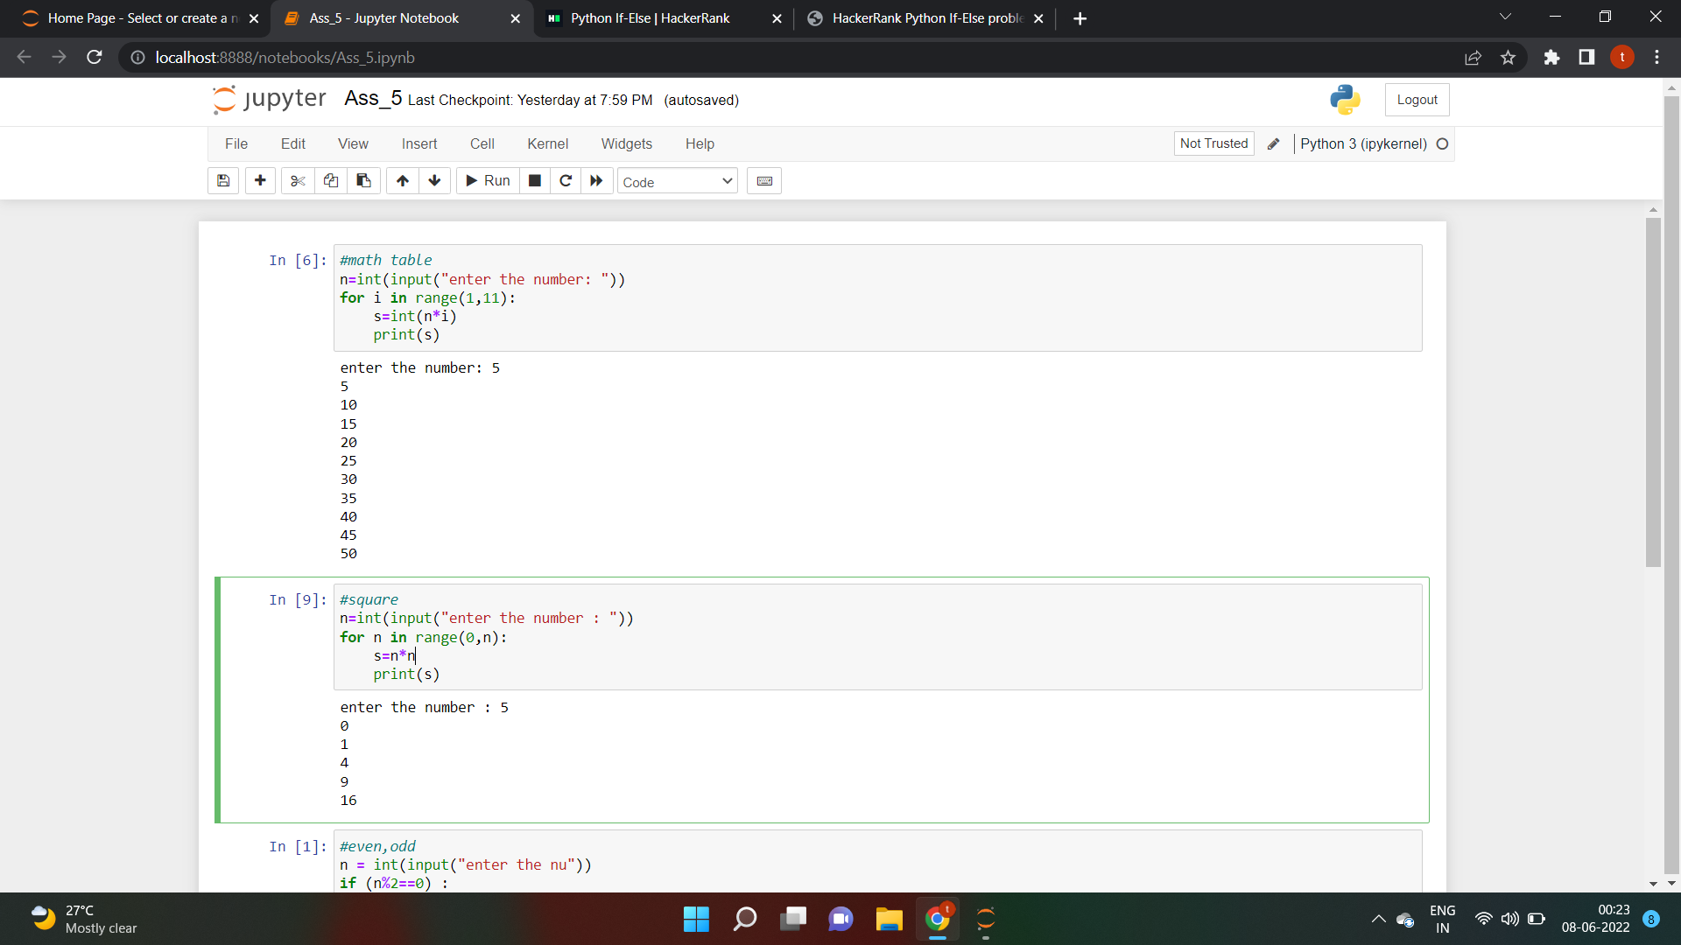

**What’s your name**

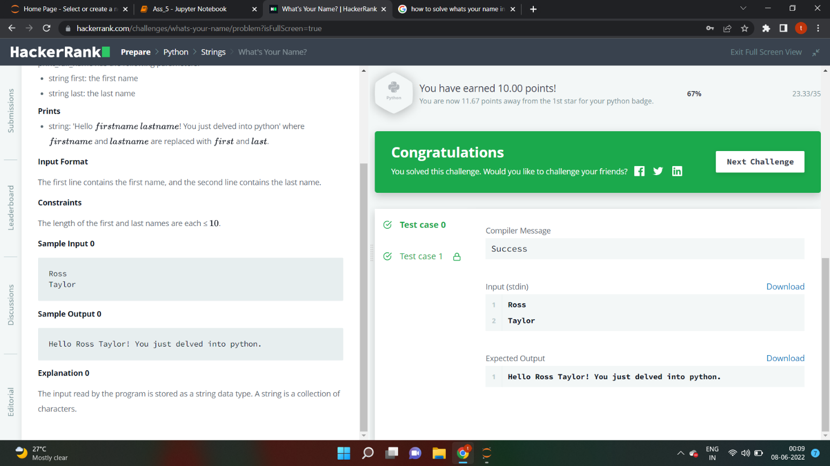

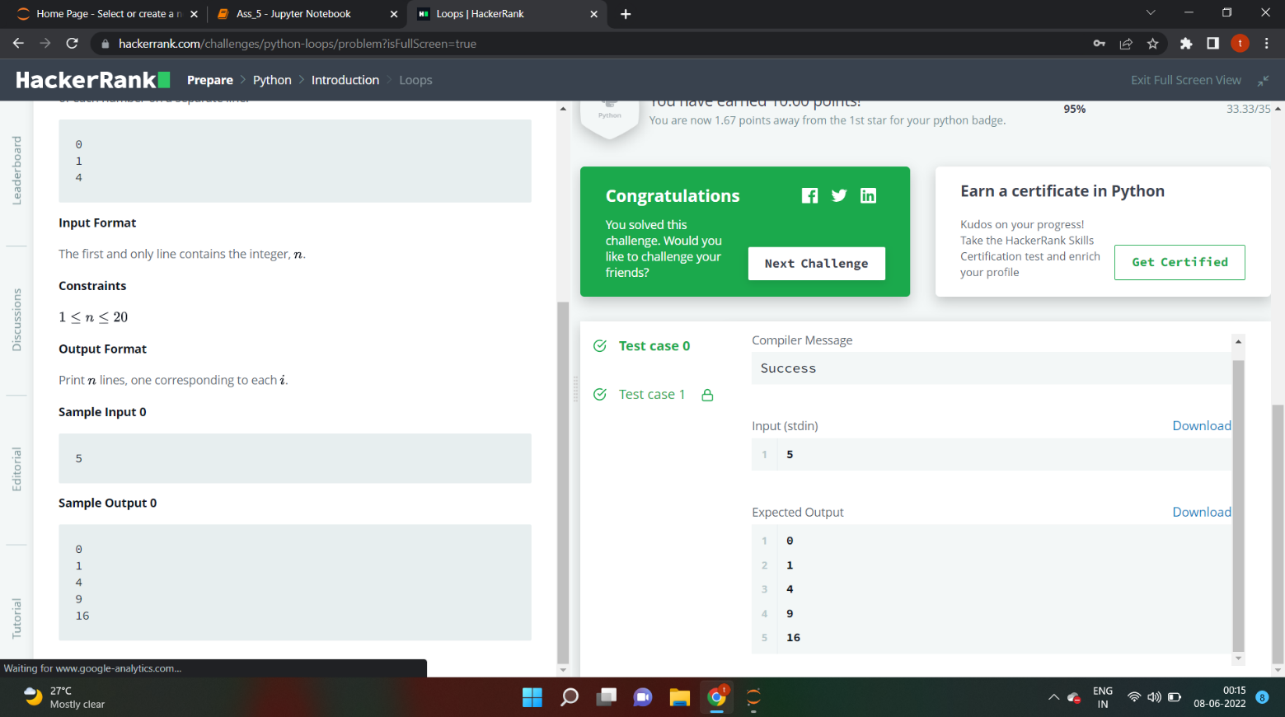**loops**

**if-else**

